**Problem Statement:**

You work for XYZ Corporation. Their application requires a storage service that

can store files and publicly share them if required. Implement S3 for the same.

**Tasks To Be Performed:**

1. Create an S3 Bucket for file storage.

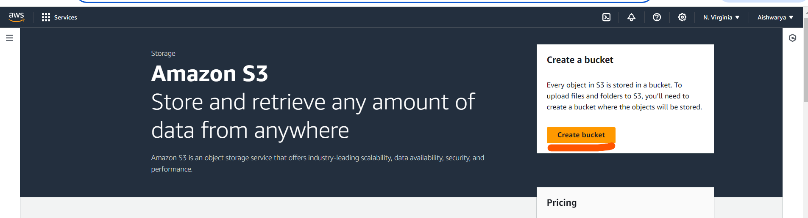

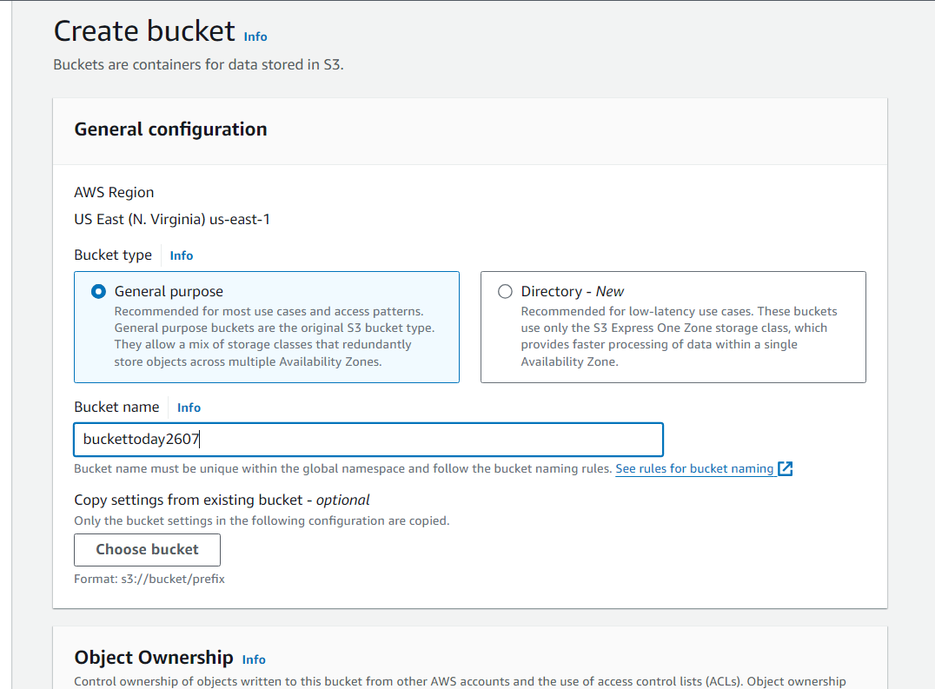

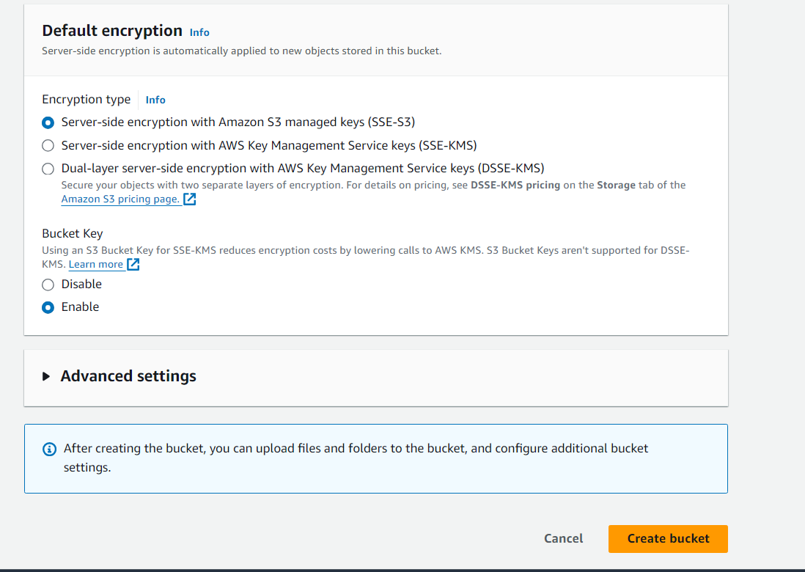

1. Upload 5 objects with different file extensions.

Go to the S3 bucket and click on upload

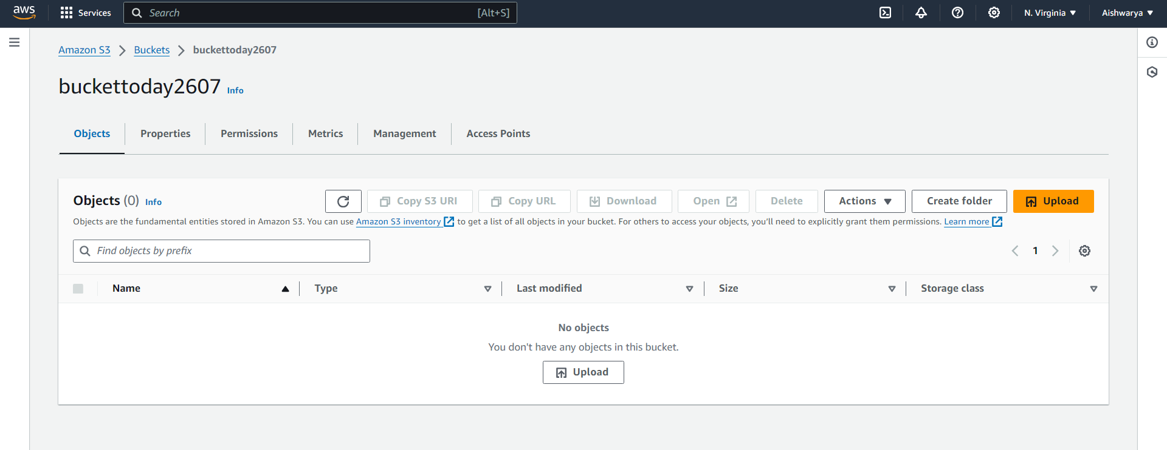

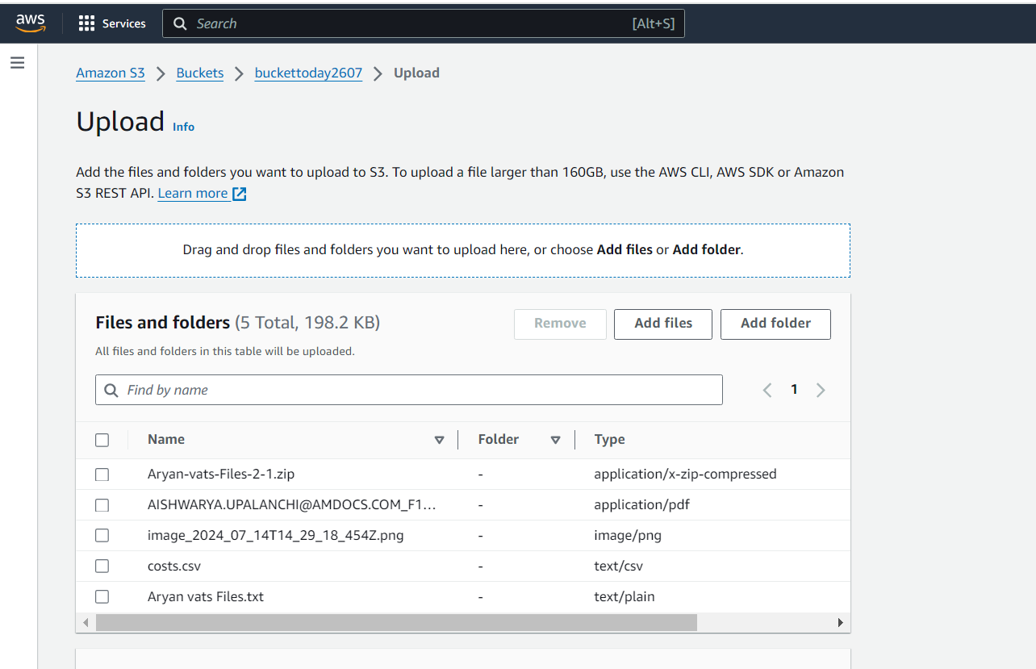

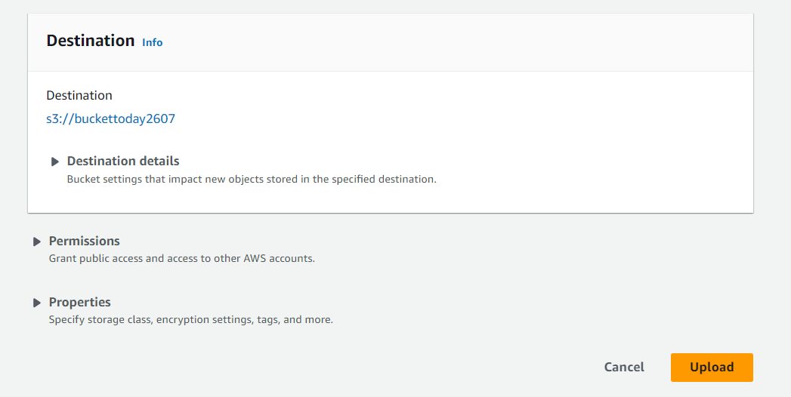

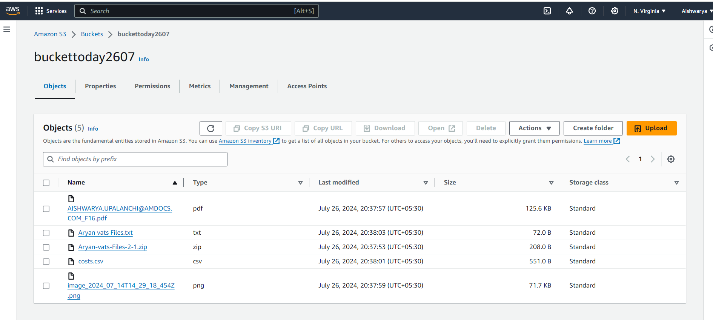

Successfully added 5 objects with different file extensions